
A Course End Project Report on
Library Management System using Java Swing and
JDBC
A9602 - Object Oriented Programming through Java Laboratory
Submitted by
Batch No. 02
Erla Krithika 25881A05DB
Course Facilitator
Mr. D. Ganesh
Assistant Professor
Department of Computer Science and Engineering
Vardhaman College of Engineering, Hyderabad
October 2026
Contents
Abstract 2
1 Introduction 3
2 Literature Review 3
3 Objectives 3
4 Methodology 4
4.1 Block Diagram 4
4.2 Classes and Components 4
4.3 Database Design 5
4.4 Working Principle 5
4.5 Software Implementation 6
5 Results and Discussion 6
6 Mapping POs and SDGs 12
6.1 Program Outcomes (POs) Mapping 12
6.2 Sustainable Development Goals (SDGs) Mapping 12
7 Conclusion 12
Bibliography 13

Abstract
In many college libraries, the details of books and the books issued to students are still written in registers. Searching for a book, checking whether it is available and finding who has taken it takes a lot of time, and mistakes are common. In this project we developed a simple Library Management System as a desktop application using Java Swing for the user interface and JDBC with a MySQL database for storing data.
The librarian can add a new book, issue a book to a member, return a book, search for books by ID or title, delete a book and view the issue log. Every issue and return is saved in the database and also written to a text file called issue log.txt. A background thread checks for overdue books every 30 seconds and refreshes the book list. The project covers the main topics of the course: classes, inheritance, interfaces, method overloading, exception handling, multithreading, collections, file handling, Swing with event handling, and JDBC.
Keywords: Library management, Java, Swing, JDBC, MySQL, OOP, exception handling, multithreading.

Introduction
A library has hundreds of books and many members. The librarian has to remember which books are available, which books are issued, to whom they are issued and on which date. When all of this is written by hand in a register, it is slow to search and easy to make mistakes, for example issuing a book that is already with another student.
A computer based library system solves this by keeping all records in a database. In this project we made a Library Management System in Java. All the books are shown in a table with their status (Available or Issued). The librarian can add, issue, return, search and delete books with a single click, and the system shows a proper message if something is wrong, such as a wrong book ID or a book that is already issued.
The project is written in plain Java without any framework. All classes are in the package library: Person, Member, Book, LibraryOperations, Library, BookNotAvailableException, DBConnection, BookDAO, LibraryGUI, OverdueChecker and Main. Each class has one clear job, which makes the code easy to understand.

Literature Review
Library automation has been used for many years to replace manual registers. Open source systems like Koha are used by many colleges, but they are large web applications that need a server and a lot of setup, which is too complex for a small department library or for learning purposes.
For building desktop applications in Java, Swing is the standard GUI toolkit that comes with the JDK [2]. It provides components such as frames, panels, tables, buttons and dialog boxes, and uses the delegation event model to handle button clicks. To store data permanently, Java provides JDBC (Java Database Connectivity) [3], which lets a Java program connect to a database such as MySQL [4] and run SQL queries using Connection, PreparedStatement and ResultSet. Keeping all database code in a separate Data Access Object (DAO) class is a common practice that separates the screen from the data [5]. Schildt [1] explains the Java concepts used in this project, including inheritance, interfaces, exceptions, threads, collections and file I/O.
Based on this, our project is made as a small desktop application that uses Swing for the screen, JDBC for the database and a text file for the issue log.

Objectives
To develop a Library Management System in Java with a graphical user interface using Swing.
To add, search, issue, return and delete books, and to show all books with their status in a table.
To store books, members and issued books in a MySQL database using JDBC.
To keep a record of every issue and return in a text file using file handling.
To check for overdue books in the background using a thread.
To apply OOP concepts such as classes, inheritance, interfaces, method overloading and custom exceptions.

Methodology

Block Diagram
The application is divided into four parts:
User Interface: LibraryGUI shows the window, the form, the book table and the buttons, and handles the button clicks.
Logic: Library keeps the books and members in an ArrayList and a HashMap, and does adding, issuing, returning, searching and deleting.
Database: BookDAO runs the SQL queries and DBConnection connects to the MySQL database librarydb.
Background thread: OverdueChecker checks for overdue books every 30 seconds.
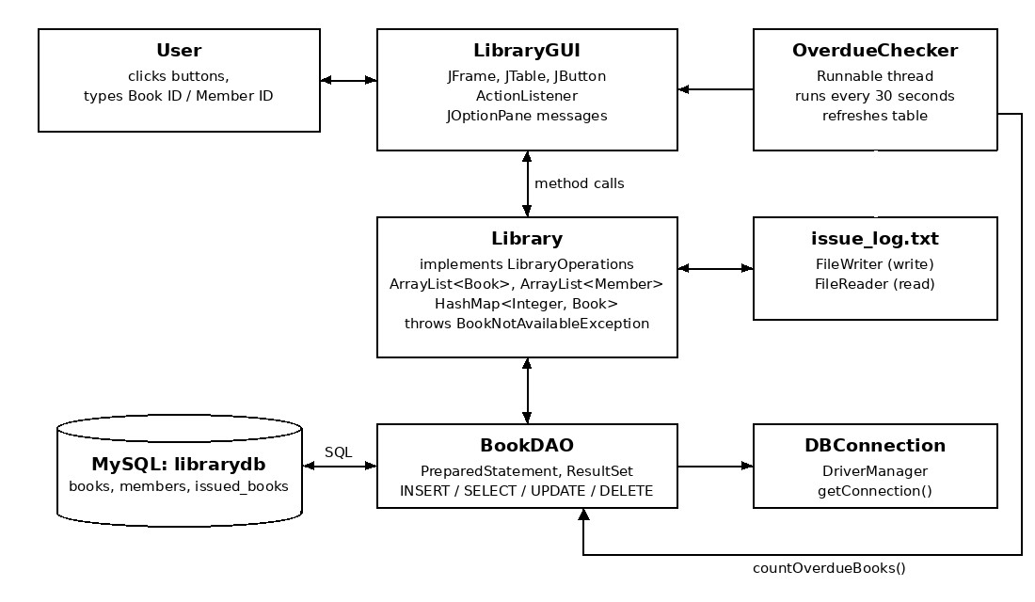
Figure 1: Block diagram of the Library Management System
Figure 1 shows how the classes are connected. When the librarian clicks a button, LibraryGUI calls a method of Library. Library checks the data, calls BookDAO to update the database and writes a line in issue log.txt. After that the table is refreshed.

Classes and Components

Components Used
Person and Member: Person has a private name. Member extends Person, adds a memberId and calls the parent constructor using super(name). It also overrides getDetails().
Book: Stores the book ID, title, author and whether the book is available. All fields are private and accessed through getters and setters (encapsulation).
LibraryOperations: An interface with the methods addBook(), issueBook() and returnBook().
Library: Implements LibraryOperations. It keeps books in an ArrayList and a HashMap<Integer, Book> for quick lookup by ID. It has two searchBook() methods, one taking an int ID and one taking a String title (method overloading). It writes the issue log using FileWriter and reads it using FileReader.
BookNotAvailableException: A custom exception that extends Exception. It is thrown when a book is not found, is already issued, was not issued, or when the member ID is wrong.
DBConnection and BookDAO: DBConnection gets a connection using DriverManager. BookDAO has all the SQL queries for insert, select, update and delete using PreparedStatement and ResultSet.
LibraryGUI: The main window (JFrame) with BorderLayout. The form uses GridLayout and the buttons use FlowLayout. It implements ActionListener and shows messages using JOptionPane.
OverdueChecker and Main: OverdueChecker implements Runnable and runs in a background thread. Main opens the window and starts the thread.

Database Design
The database librarydb has three tables, created using the file schema.sql:
Table 1: Tables in the database librarydb
Table | Columns | Purpose
books | book id (PK), title, author, available | Details of each book
members | member id (PK), name | Library members
issued books | issue id (PK, auto increment), book id  (FK), member id (FK), issue date | Which member has which book and from which date

Working Principle
- When the program starts, Main opens the window. Library loads all books and members from the database into the ArrayList and HashMap, and the books are shown in the table. The OverdueChecker thread is started.
- Add Book: The librarian enters the book ID, title and author. The book is inserted into the books table and added to the list.
- Issue Book: The librarian enters the book ID and member ID. If the book is not found, already issued, or the member does not exist, a BookNotAvailableException is thrown and a warning is shown. Otherwise the book is marked as issued, a row is added in issued books, a line is written to issue log.txt and a receipt is shown.
- Return Book: The book is marked as available again, its row in issued books is removed and the return is written to the log.
- Search: If a book ID is entered, the book is found from the HashMap. Otherwise the books whose title contains the entered text are shown.
- Delete Book, View Log and Refresh delete a book that is not issued, show the log file, and reload the table.
- Every 30 seconds the background thread counts the books issued more than 14 days ago,shows the result in the status bar and refreshes the table.

Software Implementation
Java (JDK 17): Programming language. ArrayList, HashMap and streams are used for storing and searching books.
Java Swing and AWT: Used to make the user interface (JFrame, JPanel, JTable, JScrollPane, JTextField, JButton, JOptionPane).
JDBC and MySQL: MySQL stores the data and the MySQL Connector/J driver (mysql-connector-j-8.4.0.jar) connects Java to MySQL.
Java I/O: FileWriter and FileReader are used for issue log.txt.
IDE: Visual Studio Code / IntelliJ IDEA for writing and running the code.
The code below from the Library class shows how a book is issued. It uses throw, throws, try-catch-finally and StringBuilder.
Listing 1: issueBook() method in the Library class
// Unit II: throw / throws and try-catch-finally. Returns a receipt message.
@Override public String issueBook(int bookId, int memberId) throws BookNotAvailableException { try {
Book book = bookMap.get(bookId); if (book == null) { throw new BookNotAvailableException("Book ID " + bookId + " not found");
} if (!book.isAvailable()) { throw new BookNotAvailableException("’" + book.getTitle() + "’ is already issued");
}
Member member = findMember(memberId); if (member == null) { throw new BookNotAvailableException("Member ID " + memberId + " not found");
} dao.updateAvailability(bookId, false); // Unit V: UPDATE dao.addIssueRecord(bookId, memberId); book.setAvailable(false);
writeLog("ISSUED", book, member.getName());
// Unit II: StringBuilder to build the receipt StringBuilder receipt = new StringBuilder(); receipt.append("Book Issued Successfully\n");
receipt.append("Book : ").append(book.getTitle()).append("\n"); receipt.append("Member: ").append(member.getDetails()).append("\n"); receipt.append("Date : ").append(java.time.LocalDate.now()); return receipt.toString();
} catch (SQLException e) { throw new BookNotAvailableException("Database error: " + e.getMessage());
} finally {
System.out.println("Issue request processed for Book ID " + bookId);
}
}
1
2
3
4
5
6
7
8
9
10
11
12
13
14
15
16
17
18
19
20
21
22
23
24
25
26
27
28
29
30
31
32
33

Results and Discussion
The application was tested with the sample data from schema.sql (5 books and 3 members). One book (Let Us C) was already issued 20 days earlier to check the overdue thread. All the features worked correctly. The screenshots below are taken from the application on 25 October 2026.
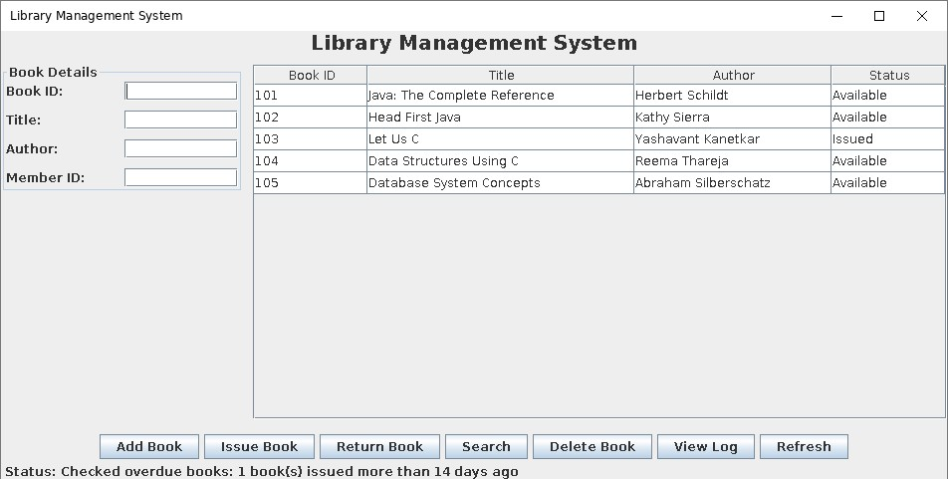
Figure 2: Main window of the Library Management System
Figure 2 shows the main window. The form is on the left, the list of books with their status is in the middle and the buttons are at the bottom. The status bar shows the message from the background thread: one book has been issued for more than 14 days.
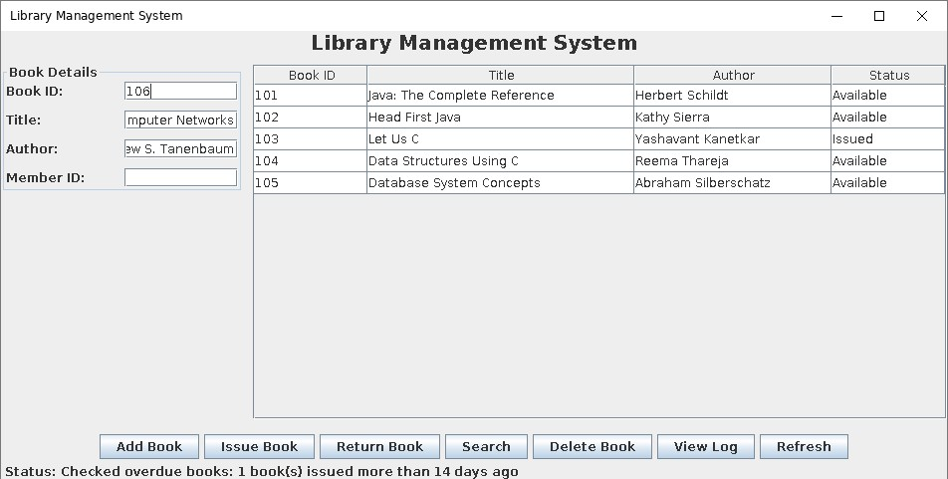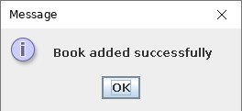
Figure 3: Adding a new book
In Figure 3, a new book “Computer Networks” with ID 106 is added. After clicking Add Book, the message “Book added successfully” is shown and the book appears in the table.
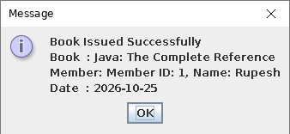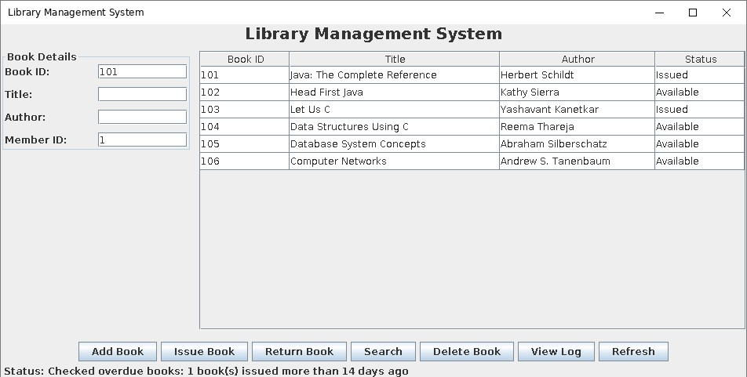
Figure 4: Issuing a book: receipt and updated table
Figure 4 shows book 101 being issued to member 1. The receipt shows the book, the member and the date, and the status of the book in the table changes to “Issued”.
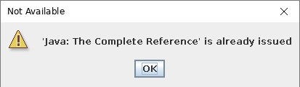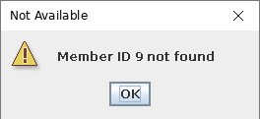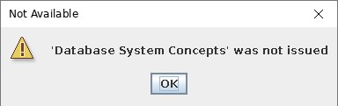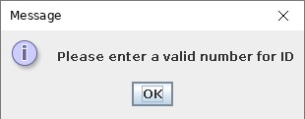
Figure 5: Error messages from exception handling
Figure 5 shows how errors are handled. Issuing a book that is already issued, using a member ID that does not exist, and returning a book that was not issued all throw BookNotAvailableException, which is caught in the GUI and shown as a warning. Typing letters in the Book ID field causes a NumberFormatException, and the message “Please enter a valid number for ID” is shown.
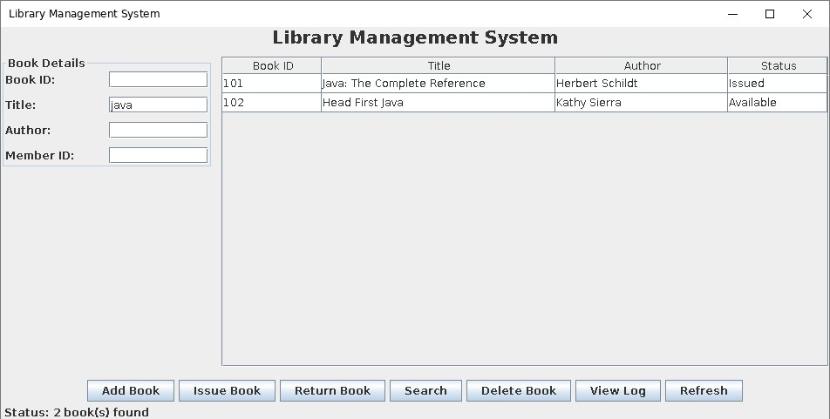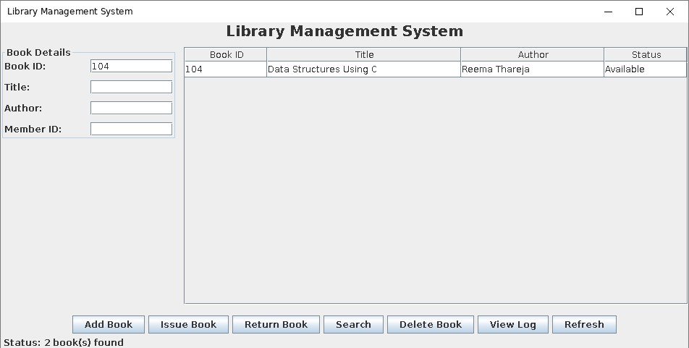
(a) Search by title “java” (b) Search by ID 104
Figure 6: Searching books (method overloading)
Figure 6 shows both search methods. Searching by title calls searchBook(String) and shows the two Java books. Searching by ID calls searchBook(int) and shows only book 104.
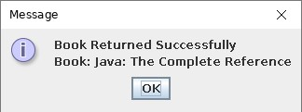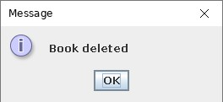
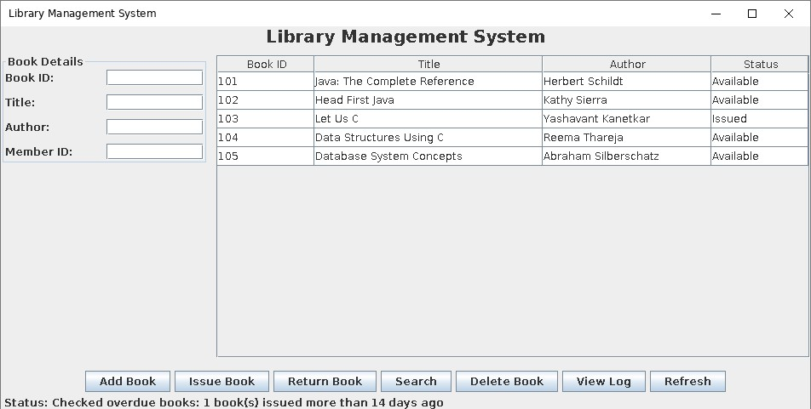
Figure 7: Returning and deleting a book
In Figure 7, book 101 is returned and its status becomes “Available” again. Book 106 is then deleted and is removed from the table.
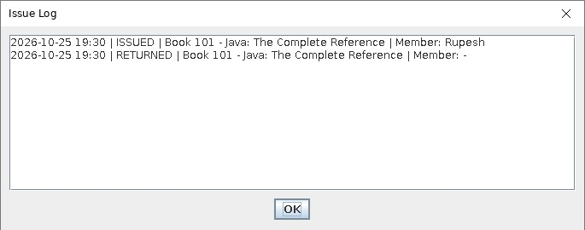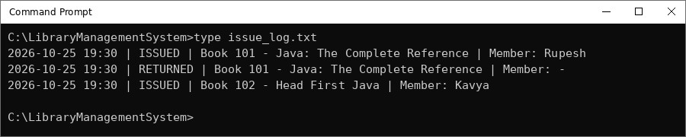
Figure 8: Issue log shown in the application and the issue log.txt file
Figure 8 shows the issue log. Each issue and return is saved as one line with the date, time, book and member. The same lines are seen when the file is opened in Command Prompt, along with a later issue of book 102 to member 3.
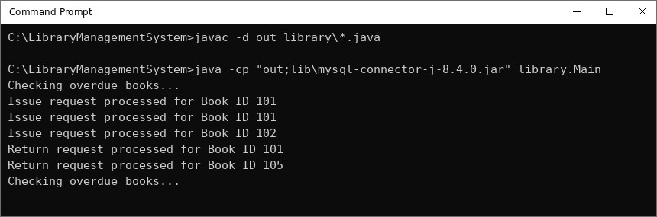
Figure 9: Compiling and running the program in Command Prompt
Figure 9 shows the console output. The message “Checking overdue books...” is printed by the background thread every 30 seconds, and the “request processed” lines are printed by the finally blocks of issueBook() and returnBook(), even when an exception occurred.
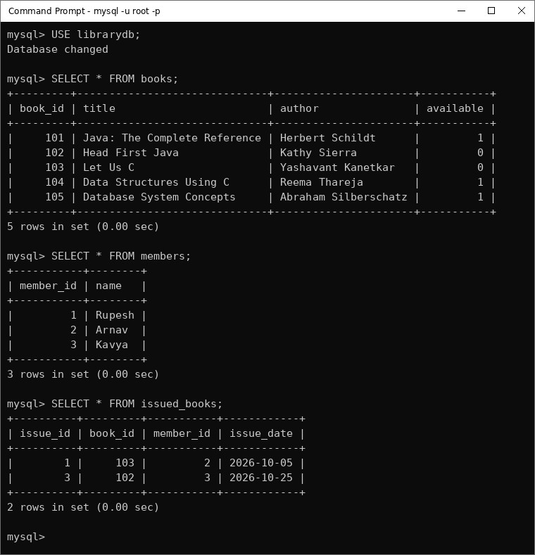
Figure 10: Data stored in the MySQL database
Figure 10 shows the three tables in MySQL after issuing book 102 to member 3. Book 102 and book 103 have available = 0, and both are listed in the issued books table with their issue dates. This confirms that the JDBC insert and update operations work correctly.
The application responds quickly and all wrong inputs are handled with clear messages. The limitations are that there is no login for the librarian and no fine calculation. In future, a login system, fine calculation, due date reminders and a member management screen can be added.

Mapping POs and SDGs

Program Outcomes (POs) Mapping
Table 2: Mapping of Program Outcomes (POs) to Project Relevance
PO No. | Program Outcome | Relevance
PO1 | Engineering Knowledge | Applied OOP, exception handling, multithreading, collections, file I/O and JDBC concepts in Java.
PO2 | Problem Analysis | Identified the problems of manual library registers such as slow searching and wrong entries.
PO3 | Design/Development of Solutions | Designed a desktop application with a GUI, a logic layer and a database.
PO5 | Modern Tool Usage | Used the JDK, Java Swing, JDBC, MySQL and a modern IDE.
PO11 | Project Management and Finance | Planned, developed and tested the application within the course timeline.
PO12 | Life-long Learning | Learned database connectivity and background threads beyond the lab exercises.

Sustainable Development Goals (SDGs) Mapping
Table 3: Mapping of Sustainable Development Goals (SDGs) to Project Relevance
SDG No. | Goal | Relevance
SDG 4 | Quality Education | Makes it easier for students to find and borrow library books.
SDG 9 | Industry, Innovation and Infrastructure | Brings digital record keeping to college libraries.
SDG 12 | Responsible Consumption and Production | Replaces paper registers with digital records.

Conclusion
This project successfully implements a Library Management System using Java Swing and JDBC with MySQL. The librarian can add, issue, return, search and delete books, and see the status of every book in a table. All data is stored in the database, every issue and return is written to a log file, and a background thread checks for overdue books. Wrong inputs are handled using exceptions with clear messages. The project helped us understand and apply all the main topics of the course in one application. In future, a login system, fine calculation and reminders can be added.

Bibliography
- H. Schildt, Java: The Complete Reference, 11th ed. New York, NY, USA: McGraw-Hill Education, 2018.
- Oracle Corporation, “Creating a GUI With Swing,” The Java Tutorials. [Online]. Available: https://docs.oracle.com/javase/tutorial/uiswing/
- Oracle Corporation, “JDBC Database Access,” The Java Tutorials. [Online]. Available: https://docs.oracle.com/javase/tutorial/jdbc/
- Oracle Corporation, “MySQL 8.4 Reference Manual” and “MySQL Connector/J Developer Guide.” [Online]. Available: https://dev.mysql.com/doc/
- E. Gamma, R. Helm, R. Johnson, and J. Vlissides, Design Patterns: Elements of Reusable Object-Oriented Software. Reading, MA, USA: Addison-Wesley, 1994.

